**1’s COMPLIMENT**

**EXP NO.10:**

AIM: To get the one’s compliment of the given number or data.

ALGORITHM:

1. Load the data from memory 3000 into A (accumulator)
2. Complement content of accumulator
3. Store content of accumulator in memory 3001 (1’s complement)
4. Add 01 to Accumulator content
5. Store content of accumulator in memory 3002 (2’s complement)
6. Stop

PROGRAM:

LDA 3000

CMA

STA 3001

ADI 01

STA 3002

HLT

INPUT:

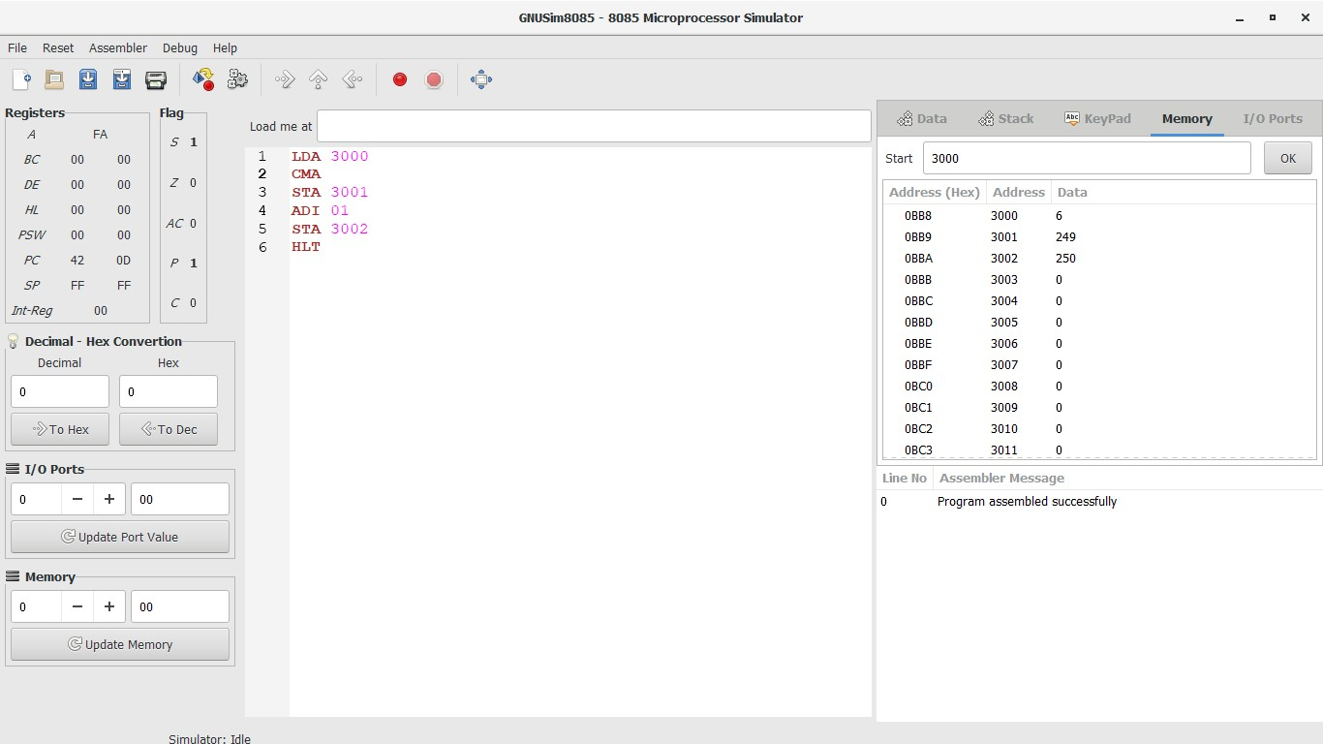

OUTPUT:



RESULT:

Thus the one’s compliment of the given data is obtained using 8085 logisim.